# 1st flush – FLATS

**1ST DAY:** **1st pass: - separation size 25 ÷ 30 mm**

**2nd pass: - separation size 25 ÷ 30 mm → if need**

**2nd DAY:**

**1st pass: - separation size 40 ÷ 45 mm**

**2nd pass: - separation size 25 ÷ 35 mm**

**3rd DAY: 1st pass: - separation size 50 ÷ 55 mm**

**2nd pass: - separation size 40 ÷ 45 mm**

**3rd pass: - separation size 30 ÷ 35 mm → if need**

**4th DAY: 1st pass: - 85+ FLAT**

**2nd pass: - 50 ÷ 60 mm**

**3rd pass: - 35 ÷ 45 mm**

**4th pass: - 85+ FLAT**

**5th DAY: STRIP**

**2nd flush**

**1st DAY:**  **1st pass: - separation 25 ÷ 35 mm**

**2nd DAY:** **1st pass: - 55+ mm**

**2nd pass: - separation 40 ÷45 mm**

**3rd pass: - separation 25 ÷ 35 mm**

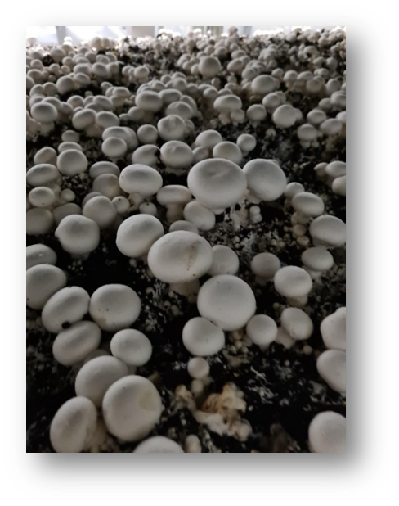

**3rd DAY:** **1st pass: - 55+ mm**

**2nd pass: 50+ mm**

**3rd pass: 45+ mm**

**4th DAY: STRIP**

**3rd flush**

**1st DAY: 1st pass: - 50+ mm**

**2nd pass: - separation 25 ÷ 35 mm**

**2nd DAY: 1st pass: - 50+ mm**

**2nd pass: - 40+ mm**

**3rd DAY:**  **STRIP**

**1st flush – CAPS**

**1st DAY: 1st pass: - separation size 25 ÷ 30 mm**

**2nd pass: - separation size 25 ÷ 30 mm → if need**

**2nd DAY:** **1st pass: - 55+ mm**

**2nd pass: - 40 ÷ 45 mm**

**3rd pass: - 25 ÷ 35 mm**

**3rd DAY:**  **1st pass: - 60+ mm**

**2nd pass: - 55+ mm**

**3rd pass: - 45+ mm**

**4th DAY:**

**1st Flush Chestnut Flats**

**1st Day:**

* 1st pass : Separation size 30÷ 35 mm
* 2nd pass:Separation 25÷ 30 mm

**2nd Days :**

* 1st pass : Separation size 40-45 mm
* 2nd pass : Separation 30-35 mm

**3rd Day:**

* 1st Pass : Separation size 50-55mm
* 2nd pass: Separation size 40-45mm

**4th Day :**

* 1st pass: 90+ Flat
* 2nd pass: 60-50 mm
* 3rd pass: 40-45 mm (if there is long stalks)
* 4th pass : 90+ Flat

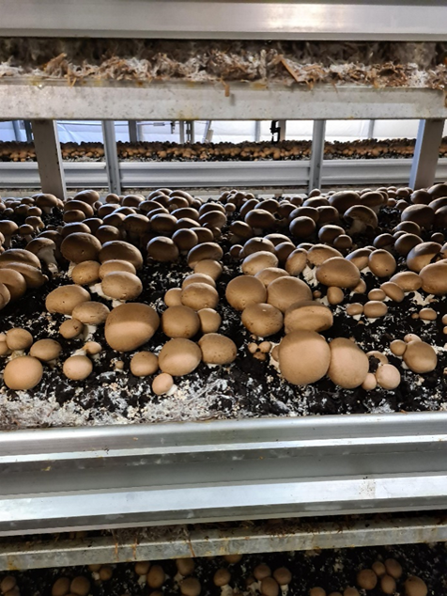

**5th Day**

Strip

**1st Flush Chestnut – CAPS**

**1st Day:**

* 1st pass: Separation size 30 -35mm
* 2nd pass: Separation size 25-30mm

**2nd Day:**

* 1st pass: 55 mm
* 2nd pass: 40-45mm
* 3rd pass: 30-35 mm

**3rd Day:**

* 1st pass: 65 +
* 2nd pass: 55+
* 3rd pass: 45-40 mm Separation from clumps
* 4th pass : long stalks – if need

**4th Day:**

* 1st pass: 70 +
* 2nd pass: 60+
* 3rd pass: 50+
* 4th pass: Long Stalks

**5th Day:**

* 1st pass: 50 +
* 2nd Pass: Strip

**2nd Flush Chestnut**

**1st Day:**

* 1st pass: Separation 30-35 mm
* 2nd Pass: Separation 25-30 mm – IF need

**2nd Day:**

* 1st pass: 55+ mm
* 2nd pass: Separation 40- 35 mm

**3rd Day:**

* 1st pass: 60 + mm
* 2nd pass: 50 +mm
* 3rd pass : long stalks

**4th day:**

* 1st pass :50 + mm
* 2nd pass: Strip

**3rd Flush Chestnut**

**1st Day:**

* 1st Pass: 55+
* 2nd Pass: Separation 30-35 mm

**2nd Day:**

* 1st Pass: 55+
* 2nd pass: 45+
* 3rd pass: long stalks A picture containing food, covered, piece, table

  Description automatically generated

**3rd Day:**

* 1st Pass: 50 +
* 2nd Pass: Strip